(7,An), (3,Be), (11, Cu), (4, Da), (8, Gi), (16, En), (21, Ba), (5, Go)

hash(k) = (17k - 13) mod 8

|  |  |  |  |  |  |  |  |  |
| --- | --- | --- | --- | --- | --- | --- | --- | --- |
| k | 7 | 3 | 11 | 4 | 8 | 16 | 21 | 5 |
| hash(k) | 2 | 6 | 6 | 7 | 3 | 3 | 0 | 0 |

Chain:

(7,An) -> [2]

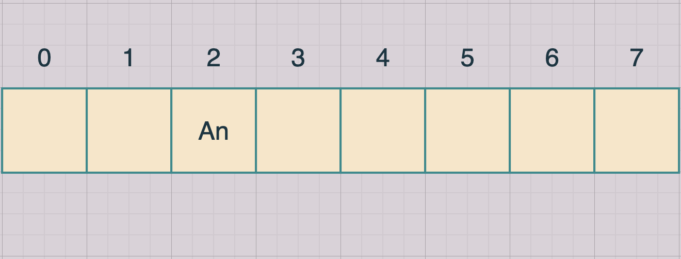

(3, Be) -> [6] 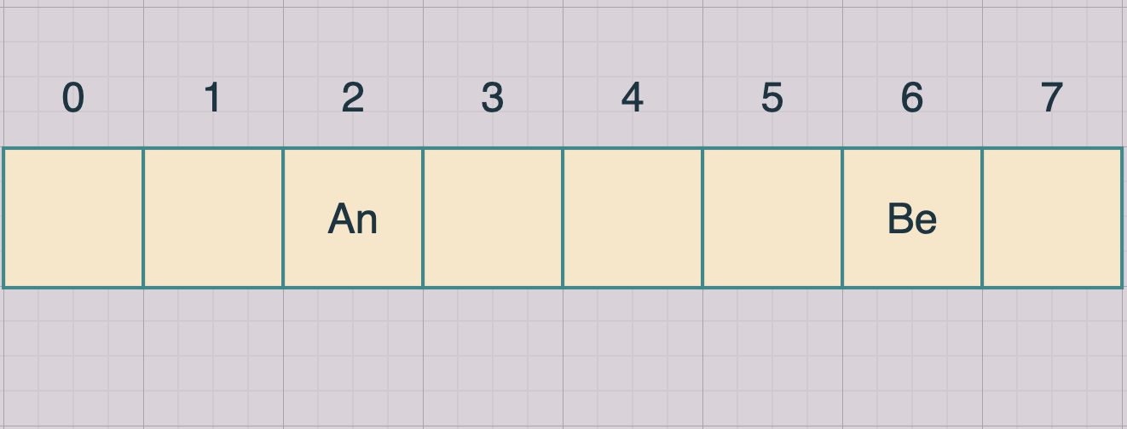

(11,Cu) -> [6] 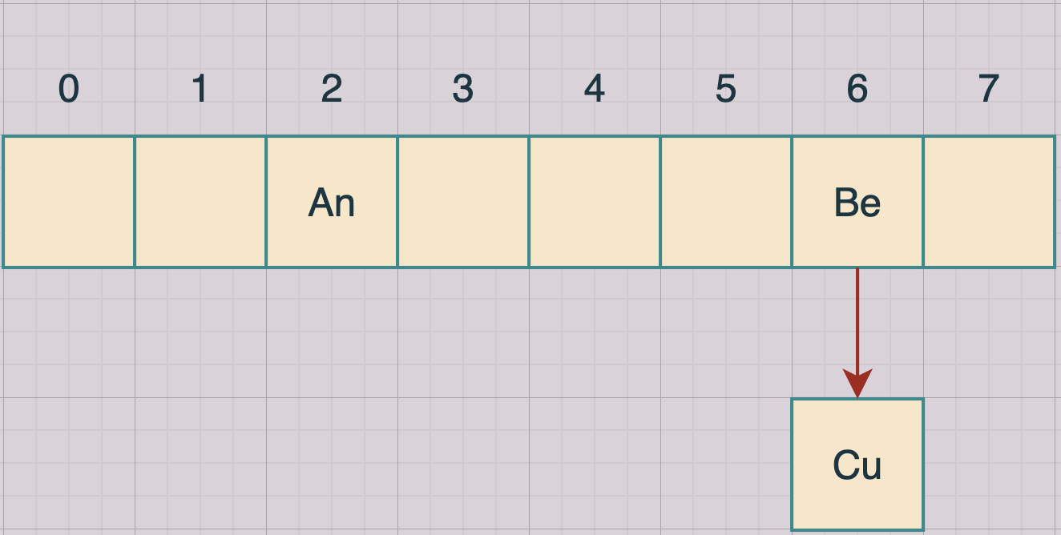

(4,Da) -> [7]

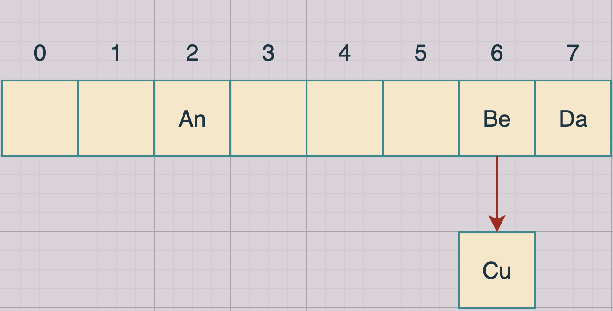

(8,Gi) -> [3] 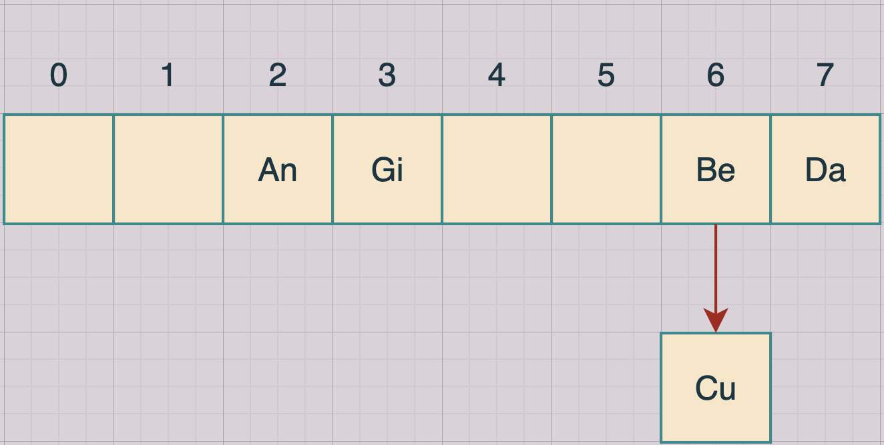

(16,En) -> [3] 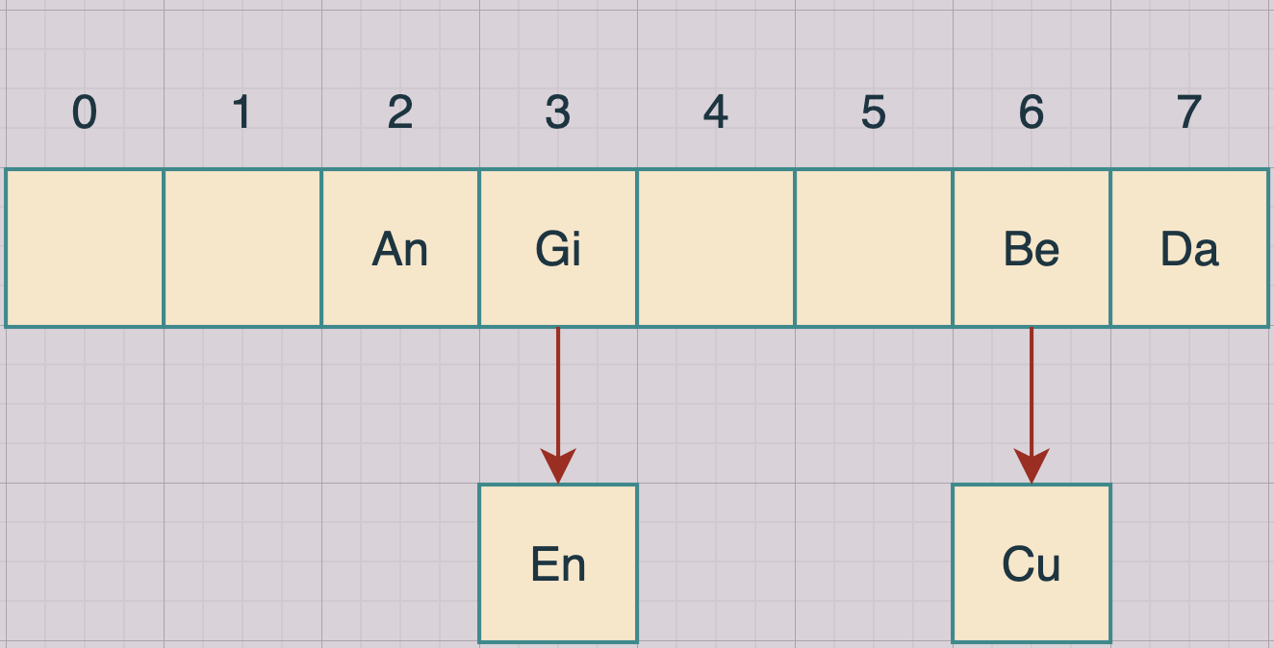

(21,Ba) -> [0] 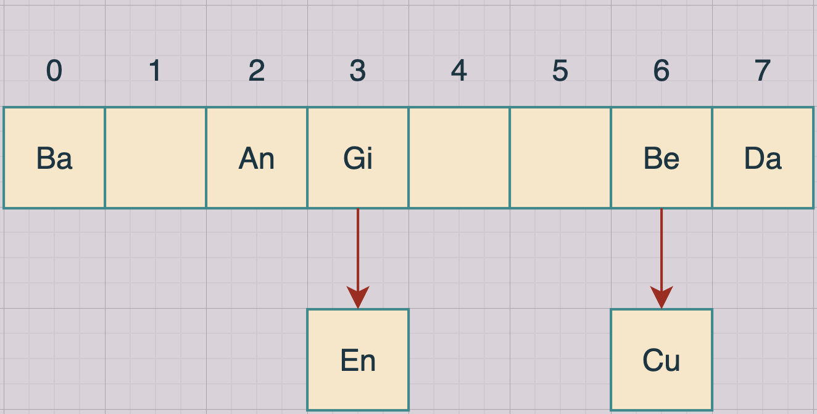

(5,Go) -> [0] 